**Institute of Engineering & Technology**

**Devi Ahilya Vishwavidyalaya, Indore (M.P)**

**Department of Computer Science & Engineering**



**Hands-on Android Programming (CER4L2)**

**Android Project :- HAPPY PLACES**

**Submitted To: Submitted By:**

**Er. Shyam Maheshwari Sir Tanishq Chauhan(21C4184)**

**CS-Dept CS “B” 2nd Year**

**IET-DAVV**

**HAPPY PLACES**

**Have a Happy Journey with Happy Place**

**Problem Statement :-** Sometimes we think about a destination or someone told us but after some time we forget about that place when we want to plan a trip.

**Is it also happening with you?**

**Don’t Fear, “HAPPY PLACES” is here**

**Solution:-** To solve this problem, Here I am going to develop an app, in that, whenever you think or listen about a new place create a card/list and add the name of the place in the title with some description that you know or listen to to about the place. You can also add an image or as well as location. So after that whenever you plan a trip you don't have to wander.

**Have a HAPPY JOURNEY WITH HAPPY PLACES**

**Here I am adding some screenshots of the HAPPY PLACES below:**

**MainActivity**

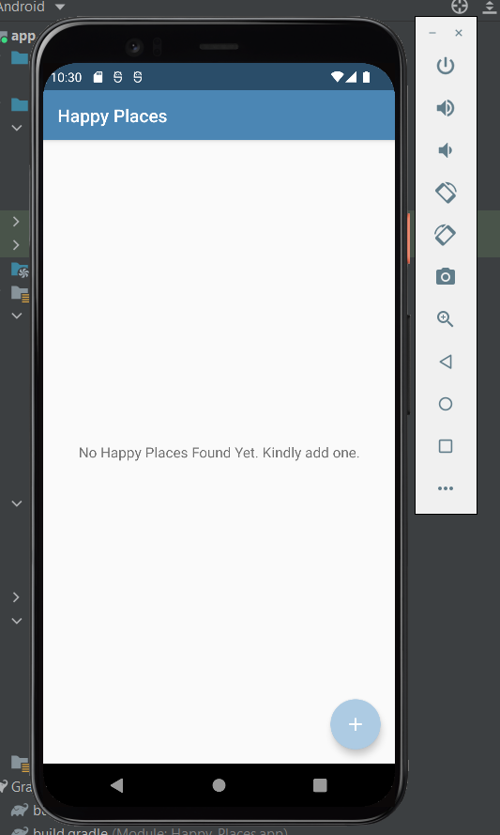

* This is the main activity page of the **HAPPY PLACE**.
* Where you can see all your **HAPPY PLACES**.
* You also have a **ADD** button here to direct you to **AddHappyPlaces** Activity.
* Where you can add you Happy Places.

**AddHappyPlace Activity**

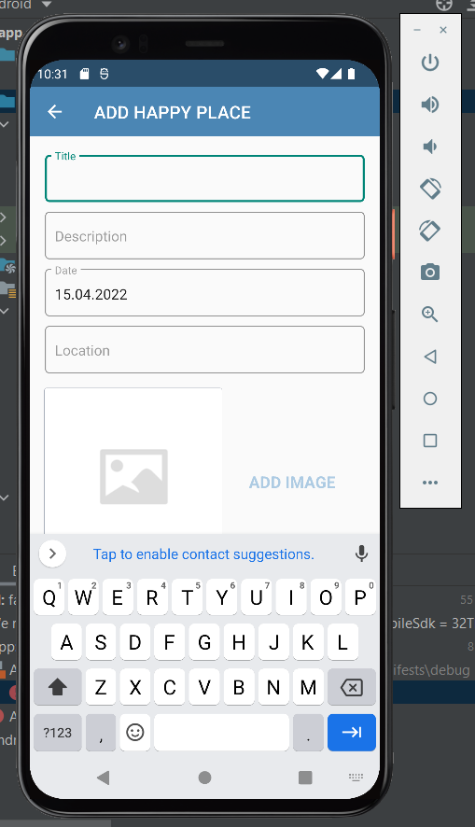

* This one is the **AddHappyPlace Activity** page.
* Here you can add your all the wishlisted Happy Place where you want to travel in your lifetime.
* There is some basic steps or fullfill the data to add a Happy Place.
* You can see all the required fields on the screen.

Do you want to see some of the Happy places?

So Lets see, which I already added on my Happy Place List.

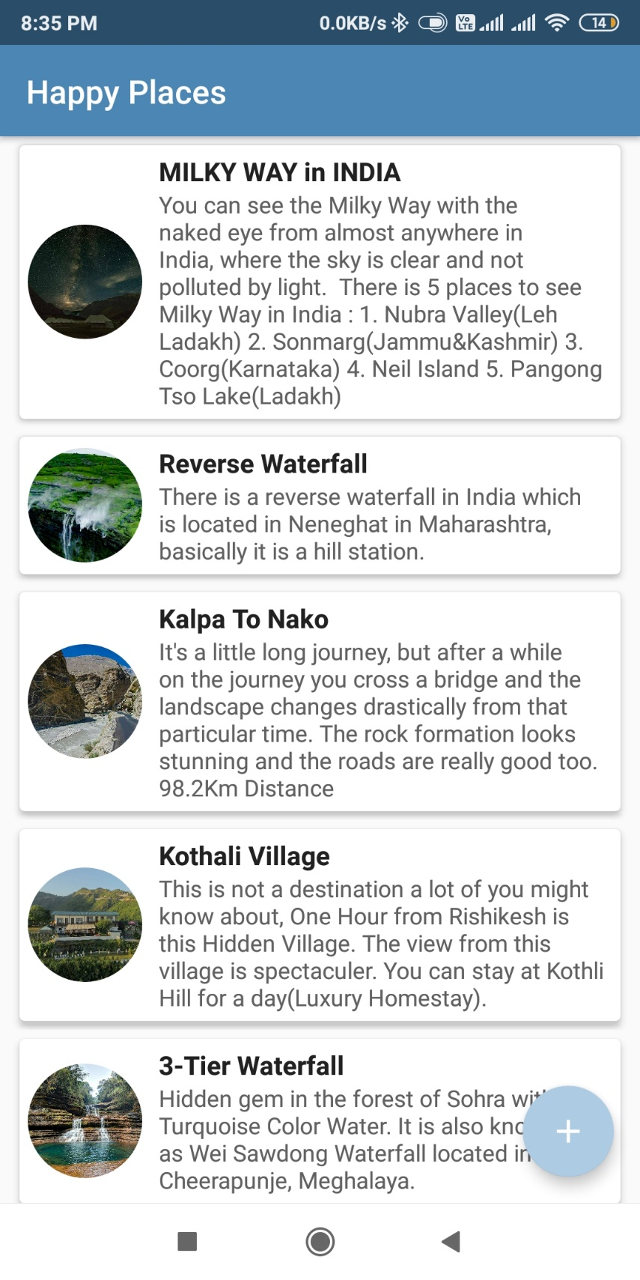

**Now, Lets create a HappyPlace for you.**

* Open the HappyPlace App
* Your will see the main page with your HappyPlaces.
* To Add New Happy Place Click on Add button to direct on AddHappyPlace Activity.

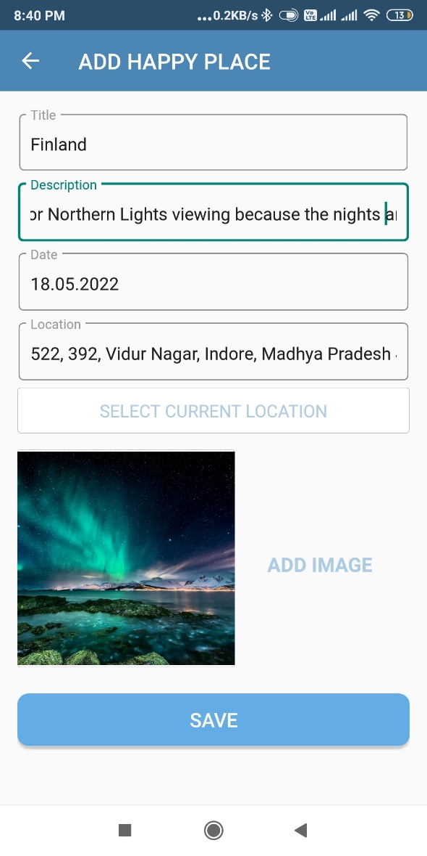

* **Title :** Name of the place/ or title.
* **Description :** Some details about the place.
* **Date :** On which date you see or some told you about the place.
* **Location :** Place where it is located.
* **Images :** Display Picture image. (Gallery/Camera)
* When we click on the **SAVE** button, we again redirect on the **MainActivity** Page where all the **HappyPlaces** are there.

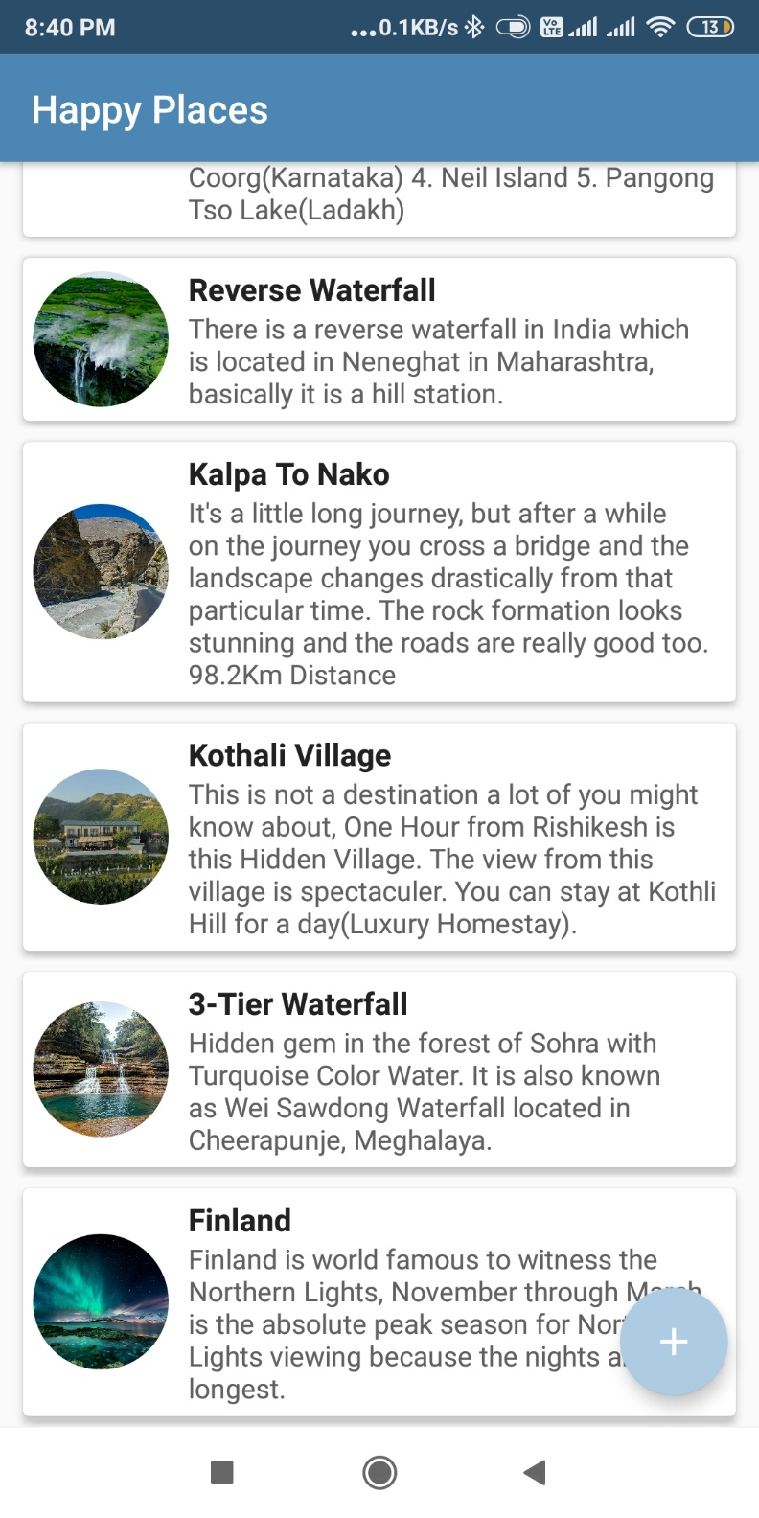

* We can also **update** this page by just right swipe.

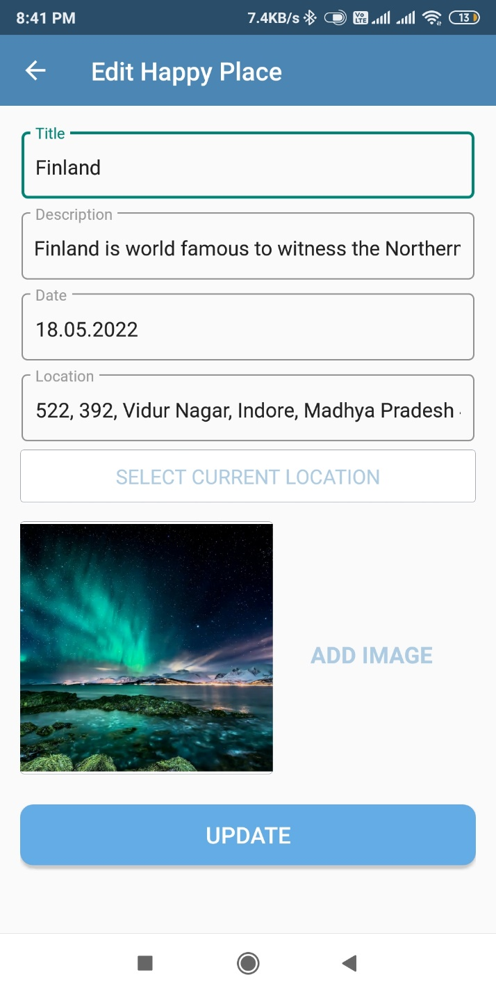

* We can also **DELETE, HAPPY PLACES** by just left swipe.

**HappyPlaceDetail Activity**

* Here you can see the **details** of the Happy Place which you added while creating or adding a new Happy Place in your list.

